Dear Parents and Caregiver
A very warm welcome to our new children and their families who have joined us recently. We trust that you enjoy a very positive partnership with Whenuapai School.
Our Sports Committee, Carli Michelsen, Chris Groen, Caitlin Neal and Alisha Geary continue to do an amazing job at increasing the number of opportunities available to our children ‘across the sporting codes’. Thank you to our families who have provided transport and sideline support over the past weeks. Alisha Geary, on behalf of the school, had ten jackets made with the school logo and name on for adults to wear when providing support with our teams. We are very excited that the PTA have offered to pay for these.
Our thoughts are with Ms Maureen Mason and her family whose father passed away this week.
Mrs Sacha Walsh has resigned her position effective the end of Term 1. We wish her well for her future endeavours. Mrs Amber Graham is returning to teach Room 21 for the remainder of the school year.
Mrs Shona Walshe my PA will be leaving us at the end of the term to join her husband in an overseas posting. Shona has been instrumental in supporting me to implement systems and processes, particularly by strengthening our communication with our parent community. We wish Shona all the very best. Mrs Jo Wright will be taking up the position at the beginning of Term 2. Jo is currently working with Shona in a part-time capacity.
Thank you to all the parents/caregivers who attended the PTA meeting this week. It was extremely well attended. Our children are very lucky to have so many enthusiastic parents wanting to provide them with wonderful extras at school.
I have attached another of Andrew Fuller’s articles, happy reading.
As always my door is always open.
We really appreciate the very many ways you support us to be the best we can be.
Kind Regards
Raewyn Matthys-Morris
Principal
Assembly
March 24th
9.15am Year 3-4
2.15pm Year 7-8
March 31st
9.15am Year 0-2
Parent morning tea to follow assembly

2.15pm Year 5-6
Thursday 13th April
9.30am – ANZAC Assembly
Board of Trustees Meeting
Monday 27th March at 5.30pm

The lost property box is located in the foyer beside the uniform shop at the back of hall. Parents are welcome to go and look at any time for missing items.

Netball Fees
Please remember these are due by the 31st March.
Any questions please see Mrs Caitlin Neal or email caitlinn@whenuapai.school.nz

Principal's Messag
Ten Hints for Creating Resilient Families
Ten Hints for Creating Resilient Families Resilience is the happy knack of being able to bungy jump through life. When the inevitable pitfalls and setbacks of life occur, it is as if you have an elasticised rope around your middle that helps you to bounce back from hard times.
Promote Belonging The sense of belonging we have is the strongest antidote we know of for self-harm, depression and drug abuse and it’s built on our sense of belonging. Children are most resilient when they have three types of belonging: 1. A sense of being part of a family 2. Having different friendships to belong to 3. Having an adult outside their family who connects with them.
Have some mooch time We live in a world that suffers from attention deficit disorder. We rush children from activity to activity, from lesson to lesson and from one organised event to another. Then we wonder why, when there is a lull that they say” I’m bored”. Be a counter-revolutionary. Find some time each week just to be at home without anything structured happening. Quiet times allow children to develop creativity and ingenuity.
Rediscover some family rituals Family rituals are string predictors of resilience. It doesn’t matter whether it is the family walk after dinner, the Sunday roast, the Friday night pizza or the Saturday morning clean up, rituals are highly protective. The best rituals often cost nothing. These are the activiteis you hope that later on your children will reminisce and say “ Mum always made sure we did.” or Dad always made sure we did.” Copyright Andrew Fuller www.anderfuller.com.au 2014 2
Spontaneity and curiosity Spontaneity and curiosity are the building blocks of good mental health. You cannot tell someone how to have better mental health and you can't give it to them by getting them to read a book. So the really hard message here is that if you want to raise your children to have mentally healthy lives you are going to have to have a good time yourself. If you want your children to succeed you need to show them that success is worth having.
Love kids for their differences When families’ function well people are allowed to be different and to be loved for those differences. We all know that children take on different roles. A father of three said, ”It’s as if they have a planning meeting once a year and say ‘ you be the good kid, I’ll be the sick kid and the other one can be the trouble-maker’! And then just when you think you’ve got it figured out they change roles again”. Having children who are strongly individual and who have a sense of who they is a sign of good parenting. The problem may, of course be that they will then express their independent spirit in ways that you don't like. The ideal is a mix between someone who preserves their own uniqueness and is able to work with others without becoming dictated to by them. Someone who has their own independent nature but is comfortable enough with themselves to allow inter-dependence.
It is clear who is in charge Families do not work well as democracies. In fact they seem to work best as benevolent dictatorships in which the parent or parents consult a lot with their children but at the end of the day, the parent has the final say. Some parents fear that if they take charge that they will lose the friendship of their children, but often the reverse is true. In families where parents fail to take their own role seriously, children may feel that to Copyright Andrew Fuller www.anderfuller.com.au 2014 3 express their independence they need to engage in risk taking behaviour and avoid responsibility. Authoritative parenting allows children to feel safe, have clear boundaries and flourish.
Consistency Consistency is the ideal. Having parents who agree on rules and standards and who convey the same sorts of messages and who value compassion over coercion, clearly has the best outcome in terms of children’s well being .It is also important that parents not be open to manipulation and work together as a team. Life however is not always so simple and we all know from sad and sour experience that parents cannot always be consistent. Sometimes parents have different value systems or can’t come to a consistent way to handle particular areas. In these situations, a second possibility is to for one parent to take charge of a particular area. This is not the most desirable solution but it is better than having parents in conflict over management issues or worse, undermining one another. In single parent families or where parents are separated the same principle applies.
Teach the skills of Self-esteem Families that work well seem to praise one another a lot. Compliments are made, positive efforts are commented on. Optimism is in the air. Even in these families, teenagers still shrug and say, “ yeah Mum” or “yeah Dad” whenever a compliment is made. Teaching the skills of self-praise is useful. One way of doing this to ask questions extensively about any achievement or accomplishment. Asking questions that like “How did you do that?”, “How come you did so well at that test?” “ What did you do?” and “Have you been doing homework behind my back?” Copyright Andrew Fuller www.anderfuller.com.au 2014 4
Know how to Argue Families that work well know how to argue. It seems strange to say this because we all have the sense those families that work well don't have conflicts. The family is really where we learn to resolve disputes fairly. The way that parents teach children to resolve differences of opinion with their brothers and sisters provides the basis for sharing, negotiating and problem solving in the world beyond the family. . While differences of opinion should be allowed to be expressed, children also need to learn that they will not be able to win at all costs
Parents are reliably unpredictable With young children it is important to provide consistency and predicability. This allows them to feel sure of you. After a while though, a bit of predicability can go a long way. To many children, most parents are about as predictable as a washing machine cycle. It is important to have structure and consistency but it is also useful to act in ways that your children wouldn’t expect. This keeps them interested in learning from you or least wondering what you are up to. Perhaps the most important feature of parents in healthy families is that they realise that all of the above is desirable but not always possible and so they look at how to promote good functioning while not wasting energy on blaming themselves for the times when things don't quite work out as they had planned.
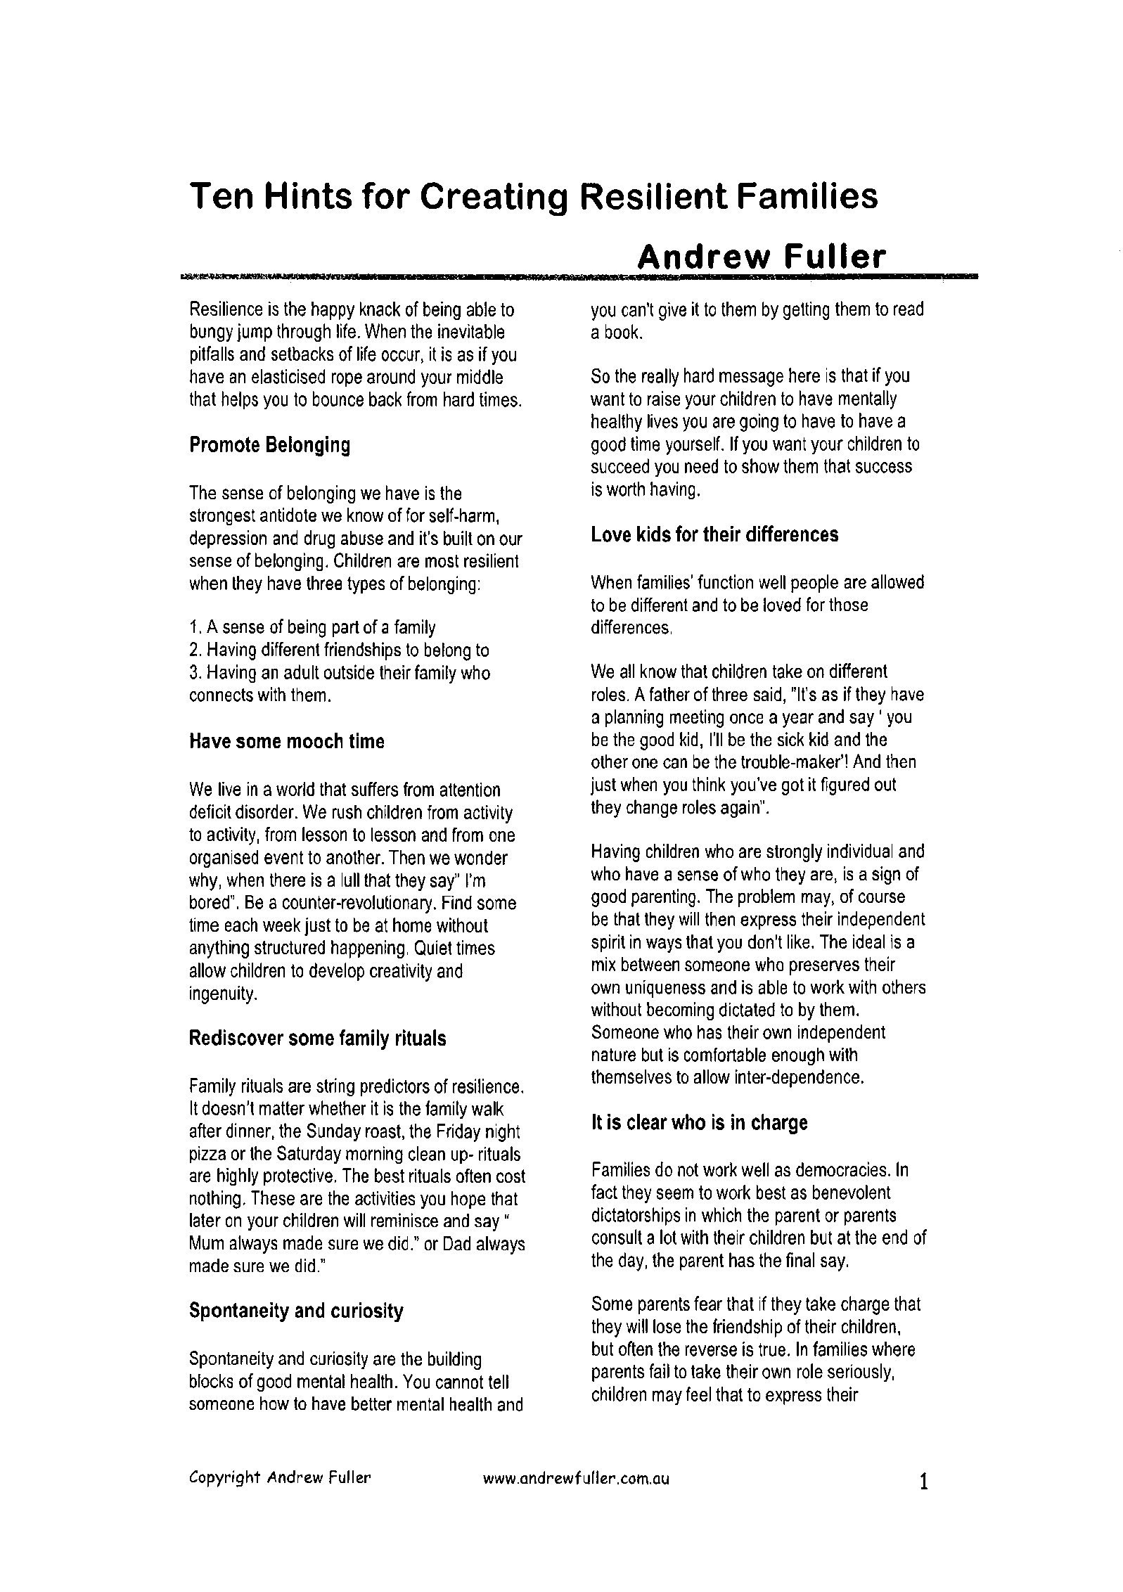

Health

The weather is changing and with this has come the bugs. This week we have been informed by parents of a case of chicken pox, students with strep throat and a number of students with a stomach virus.
- http://www.health.govt.nz/your-health/conditions-and-treatments/diseases-and-illnesses/chickenpox
- http://www.health.govt.nz/your-health/conditions-and-treatments/diseases-and-illnesses/sore-throat
- http://www.health.govt.nz/your-health/conditions-and-treatments/diseases-and-illnesses/impetigo-school-sores
The New Zealand health site has a number of conditions or illnesses that can be searched to help families understand what their child may have.
http://www.health.govt.nz/your-health/conditions-and-treatments

Scholastic Books
Brochures for the latest offer from Scholastic Books will be sent home on Friday 24th March. There is a good selection of books to choose from, including an assortment of items $10.00 and under.
Ideally orders would be placed on-line to minimize our administration time, please see instructions on the back inside page of the brochure. For those who prefer paying by credit card or cash, just fill in the form also at the back of the brochure and return with either the credit card option filled out, or the CORRECT cash amount, in a sealed envelope, with your child’s name and room number printed on the front.
Orders must be received at school by Monday 3rd April. Sorry, but no late orders can be accepted at school after this date; however the on-line ordering system will still be open for a few more days.
Sport

Basketball
Behind every fearless player there is a fearless coach who refused to let them be anything but the best they can be. This week we say thank you to the coaches and managers who stand behind their teams and help them grow in strength, skills and as a team each week. This team of volunteers spend hours encouraging and imparting knowledge to the youth at our school, your children. Take a moment to thank them this week and show your appreciation for their time and the investment they put into your kids. This type of community service is becoming a rare commodity, a service which is often taken for granted.

A battle of skill and sweat took place between an evenly matched Whenuapai Fireballs and Hobsonville Spurs. In the last seconds the Fireballs took the win by a point winning 11-10. The Slammers faced off against the Summerland Breakers and proved their hard work at training paid off winning their game 10-4. The Flyers showed some great team work on the courts this week and won their game 16-14 against the Mini Breakers. The Thunder battled it out on the court against a very strong Stripling Warriors. They lost 16-12 after a valiant effort in defence. With some great defence our little Foxes drew their game with the St Paul Rockets.We recognised Quinn, Cinamyn, Jayden, Vaugn and Meila as our players of the day for outstanding levels of play on the courts.
We are still looking for a couple more players to join the Whenuapai Thunder (under 13's age grade) . So please get in touch if you would like to play.
This event will be held on Sunday 9th April. The fun run will start at Takapuna Grammar and finish at Milford reserve.

Any questions please contact Alisha Geary, alishag@whenuapai.school.nz

Junior Tough guy and gal challenge
This is a chance for primary and intermediate aged kids to get involved in New Zealand’s biggest mud run series in a version tailored especially for them! The Junior Tough Guy and Gal challenge will include many of the same amazing perks as the adult version, such as outstanding goodie bags, challenging obstacles, incredible venues, hot showers and spot prizes.
There are two types of events you can register for:
1.5km (Year 3-40
3km ( Year 5-8)
The cost of this event is $25 which includes all entry and starter packs for the race.
For more information http://www.eventpromotions.co.nz/events/junior-tough-guy-and-gal-challenge/ or contact: Alisha Geary – alishag@whenuapai.school.nz

PTA News

Thank you to those who supported our recent sausage sizzle. We sold almost 450 sausages and had some very excited children. We have some more events coming up and will have notices for these sent home shortly.
Junior School Disco – Thursday 23rd March
Whenuapai Half Marathon – Sunday 2nd April
Ice Block Day – Thursday 13th April
Math-a-thon – Thursday 12th May
Previous newsletters, meeting minutes and notices are available on the school website under the PTA tab.

In the first week of term 2 the PTA will be holding a second hand uniform sale. This will consist of mainly jumpers and will be sold at $5 each. Tables will be placed outside the school office each day. Dates and times will be advertised before the end of this term.

The PTA we be holding a sausage sizzle fundraising event at the Whenuapai half marathon on the Sunday 2nd April.

Support Group
Parents of Children with learning / behavioural needs
Hi my name is Vivienne – I am starting a support group for parents who have children with learning or behavioural needs. I have an eight year old son who has ASD/ADHD and Dysprexia.

If you are interested or would like to know more please email Sharron Buer, sharronb@whenuapai.school.nz. Sharron will be happy to pass your contact details on.

Music

Piano /Keyboard

There are two vacancies for piano/keyboard lessons at school.
Please contact Diane Hunn on 021 653386 for further information.

Musiqhub Band Programme and “Have a Go” day:
There are still spaces available for children in year 2 and older who would like to learn clarinet, trumpet, flute, ukulele, snare drum or saxophone. Please note that not all instruments are available to every year level. If you are interested in finding out more, please contact Joanne Slagel on 027 3408 398 or joanne.slagel@musiqhub.co.nz

KEY CONTACTS

Principal | Raewyn Matthys-Morris | rmatthys-morris@whenuapai.school.nz
Deputy Principal | Carla Veldman | cveldman@whenuapai.school.nz

TEAM LEADERS
Year 0-2 | Rachel Capizzi | rachelc@whenuapai.school.nz
Year 3-4 | Catherine Collins | catherinec@whenuapai.school.nz
Year 5-6 | Maureen Mason | maureenm@whenuapai.school.nz
Year 7-8 | Sharron Buer | sharronb@whenuapai.school.nz

Board of Trustess | bot@whenuapai.school.nz
PTA | pta.whenuapai@gmail.com
SKIDS after school care | Whenuapai@skids.co.nz

ONLINE PAYMENTS
Should you have any queries please contact Mr Tony Hitchcock by email; thitchcock@whenuapai.school.nz
Bank Account details: 123085 0494188 00
Reference: students name
Details: what activity the payment is for.
If you pay online for more than one activity or pay for more than one student and various activities, please email Tony indicating what the payments are for.

